EDH Company Profile | 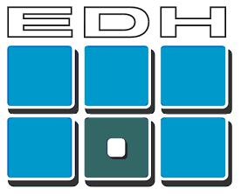
EDH was founded in 1989 as a contract developer for electronic systems, from which it developed extensive experience and a range of own products and services.
Today EDH supplies professional electronic sensor systems and software for defence, industrial, and sports applications.
FlightScope is EDH’s sports technology brand, with products and services currently for Cricket, Tennis, Golf and Baseball.
EDH formed mergers in 2002 and 2006 to establish and expand its professional services business for Tennis event management, scoring and display.

Organization and Location
  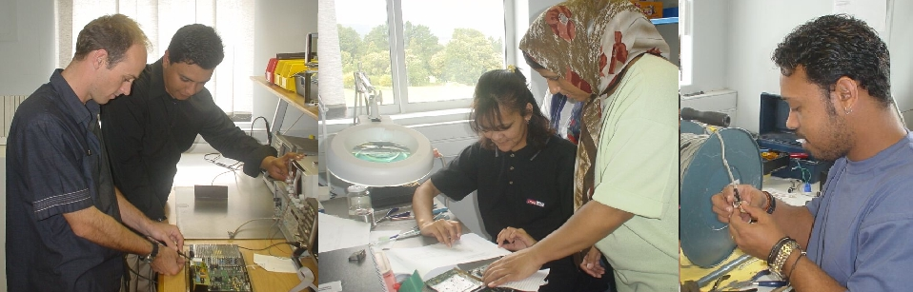  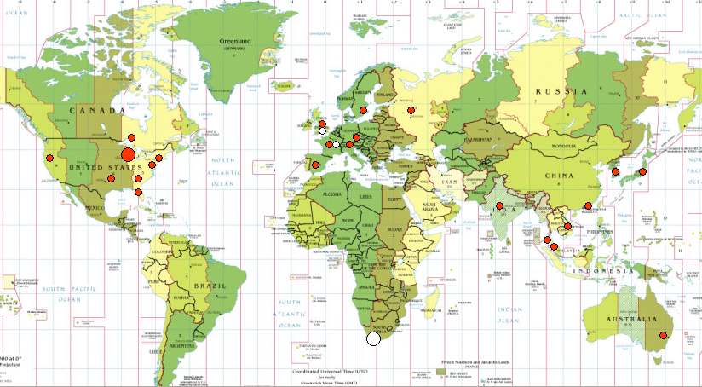 | OWNERSHIP  The company is privately owned. In 2006 EDH entered into an equity agreement with HBD Business Holdings, see www.hbd.com.  STAFF  The company employs approximately 50 people including engineers, scientists and technicians, as well as administrative, and marketing staff.  LOCATIONS AND OPERATIONS  The company head office is based in Stellenbosch, South Africa, with Marketing, Sales, Development, Manufacturing, and Support divisions housed in its various subsidiary companies.  Marketing and sales operations are conducted from EDH’s office in the USA. The office is located in Winter Garden on the outskirts of Orlando, Florida.  R&D and Manufacturing operations are based on the Technopark in Stellenbosch, South Africa. EDH is an ISO9001:2000 certified manufacturer.  Subsidiary companies in the UK and Poland house the Tennis services business.  Sales and technical support are supplemented through a distributor network in the UK, Europe, the far East, and Australia.

FlightScope Sport Markets and Products
FlightScope® is the brand name of EDH’s measuring technology and specialized software and event services for various sports.

Cricket
The first application of FlightScope was in Cricket where the now well-known Speedball measures the speed of a bowled ball. Measurements are done automatically and fed to display boards and TV broadcasts.  Bowling speed measurement has now become an expected feature of TV match broadcasts and fieldside displays. | 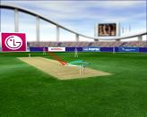

Golf
FlightScope for Golf was first used commercially in 2002 as an OEM sensor system that tracks golf clubs and balls for indoor golf simulator systems.  FlightScope launch monitor and ball-tracking system in standalone application was first launched in 2003 at several driving ranges in the several far East countries. Today, FlightScope is the world’s top ball-tracking system for golf, providing true trajectory and speed measurement of golf balls and clubs in both indoor and outdoor applications such as golf club fitting, teaching, entertainment, and equipment testing.  FlightScope has also been used in several television broadcast events of golf events and tournaments. | 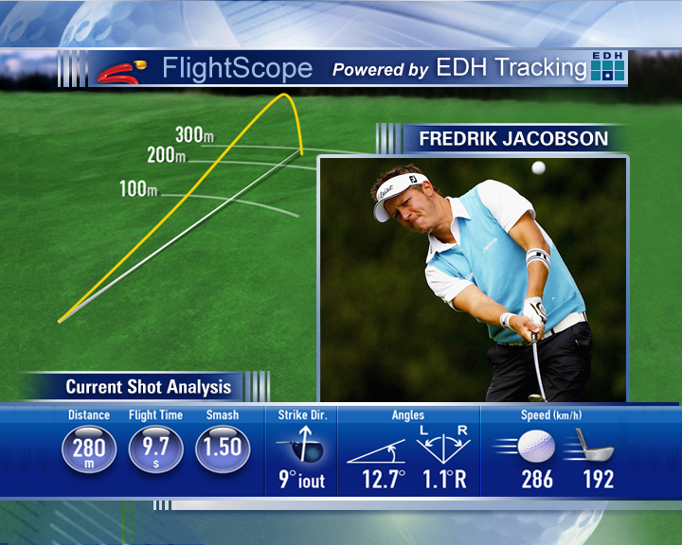

Tennis
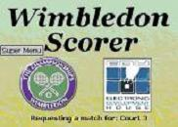 | FlightScope provide top professional tennis organizations and tournaments with software for event management (entries, draws, scheduling of matches, match scoring) as well as serve speed and 3D tracking display, with web and TV outputs.  FlightScope Tennis systems and services are used by the world’s major tennis events including the ATP, ITF Davis Cup and Federation Cup, Wimbledon championships, Queens, China Open, the 2008 Beijing Olympics. Two Tennis in Japan are contracted for the 2009 season. | 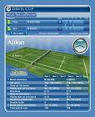

Baseball
FlightScope has also been adapted for baseball use,with first commercial use in the Doha Asian Games in 2006.  System applications include pitch ball speed and tracking, as well as batted ball tracking. Tested with Major League Baseball and ESPN in the USA.  Suited to television broadcast of live baseball matches.  Also suited to practice and entertainment hitting cages. | 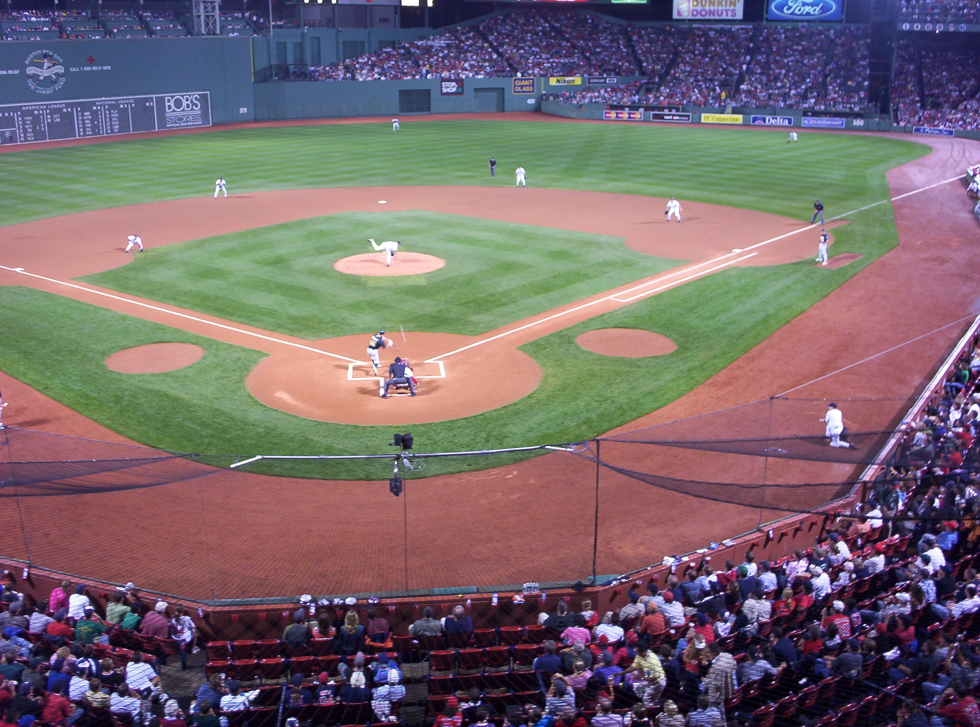

Other Sports
Various other professional sports can be supported by FlightScope software and sensors.

Machine Vision and other Industrial Systems

EDH manufactures visual inspection systems for use in quality control in manufacturing environments.  Own-developed camera systems and software are applied in a variety of industrial inspection applications.  Manufactured item defects are detected, counted and eliminated during manufacturing. |  | 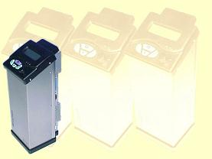
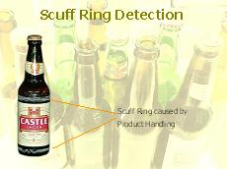 | Projects and industries covered include:  - Chemical propellants  - Ammunition labeling and identification  - Food and food packaging  - Beverage closures and bottling  - Aircraft position measurement  - Sports applications  - Nuclear power station components  - Automotive parts  - Biomedical (neurosurgery)

Contact Information
EDH US, LLC  1232 Winter Garden Business Park  Suite 120  Winter Garden, FL 34787  USA | Telephone +1 407 347 5263  e-mail sales@flightscope.com  Web www.flightscope.com
EDH (South Africa)  10 Elektron Street  Technopark,  Stellenbosch 7600  South Africa | Telephone +27 21 880 2160  e-mail admin@edh.co.za  Web www.edh.co.za
EDH Tennis Limited  Glebe View House  Collingbourne Kingston  Marlborough, Wiltshire SN8 3SE  United Kingdom | Telephone +44 2081 334 489  Web www.flightscopetennis.com

